**HOW TO USE**

To use this application , first we need to install the application through apk. file or simply render it into web directly through code.

From the home page we can use this application wth or without logging in.

To login, use login page and admin credential are [aa@aa.aa](mailto:aa@aa.aa)

Psswrd=a.

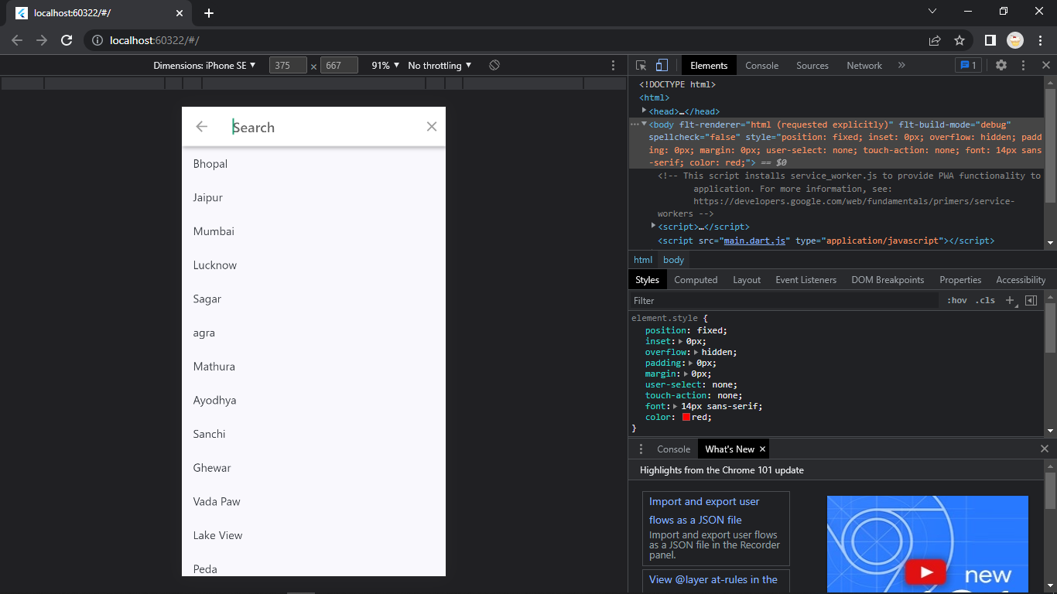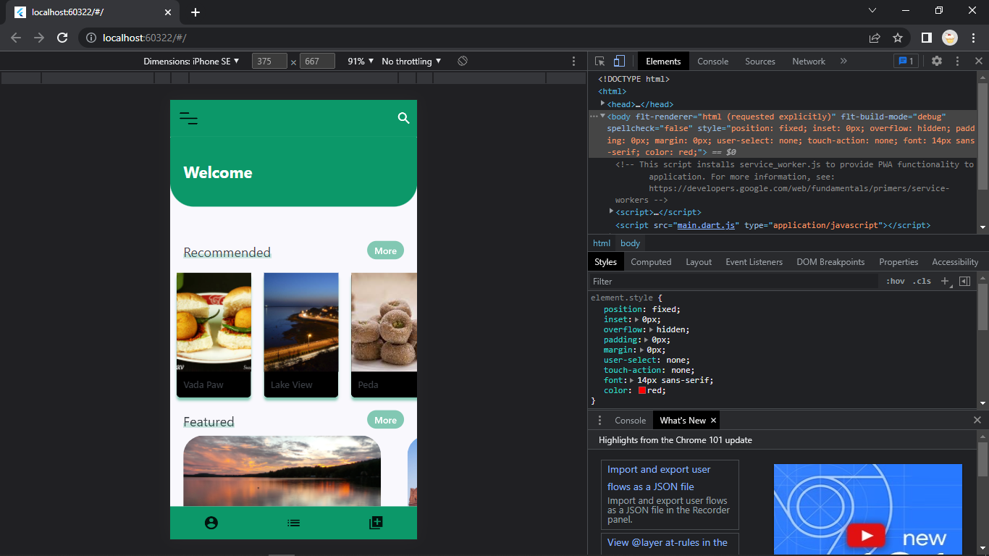

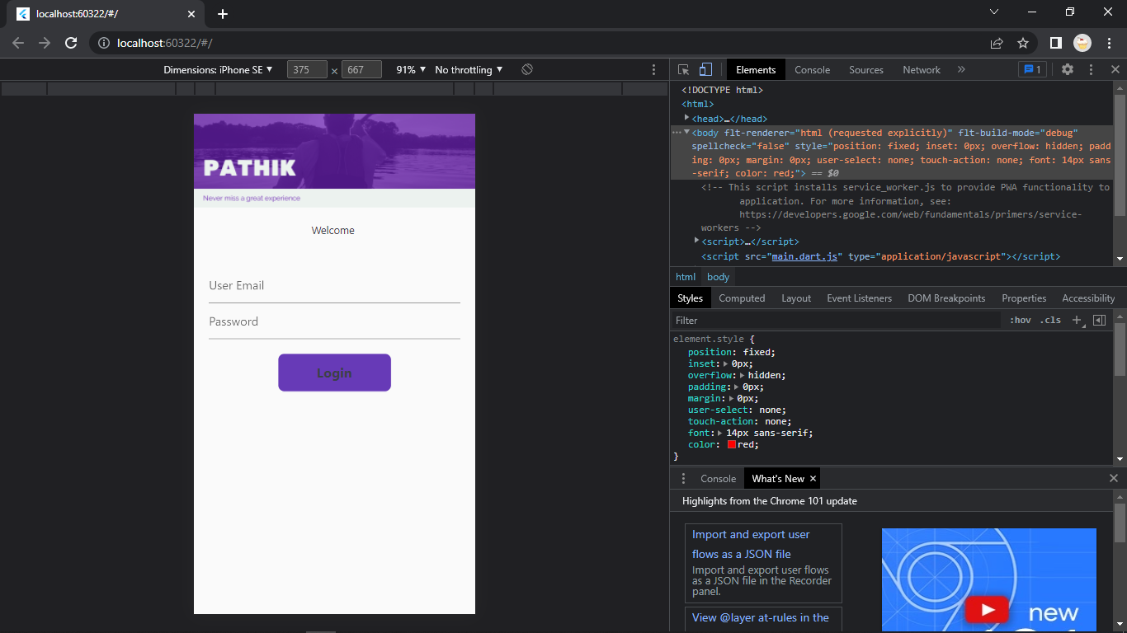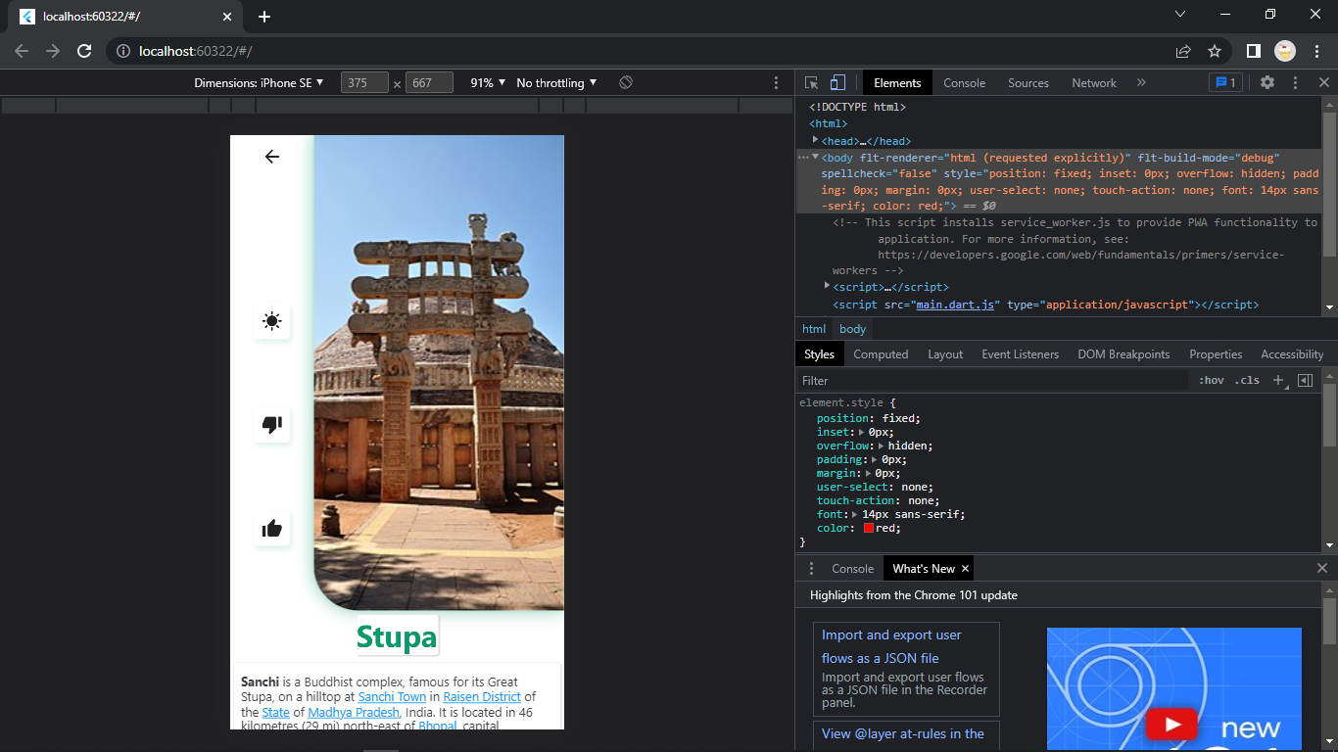

You can look for the things that are being suggested or recommended on the home screen or directly use search bar to search for the location and a list of items will be listed to choose from ,

On clicking on any item of the list a descriptive page will show up for extra details like adding like ,dislike and dark-switching mode